**Submitted to: Dr. Devon Lin**

**Submitted by: -Hardik Uppal**

**Student number: -20132445**

STAT862

Assignment 2

**1. Answer the following questions.**

**(a) On average, what fraction of people with an odds of 0.4 of defaulting on their credit card payment will in fact default?**

P(x)/1-P(x) = 0.4 = odds

P(x) = 4/14 = 0.2857143

**(b) Suppose that an individual has a 18% chance of defaulting on her credit card payment. What is the odds that she will default**?

Odd = p(x)/1-p(x)

=0.18/1-0.18

=0.219

**2. Consider the data set Auto in the R package ISLR. We wish to develop a model to predict whether or not a given car gets high or low gas mileage.**

**(a) Create a binary variable, mpg01, that contains a 1 if mpg contains a value above this median, and a 0 contains a value below its median.**

library(ISLR)

autodf=data.frame(Auto)

autodf$name= NULL

autodf$origin= NULL

autodf$mpg01 = 0

autodf$mpg01[autodf$mpg>=median(autodf$mpg)] = 1

summary(autodf)

attach(autodf)

Now mpg01 variable is a new column in our dataframe(autodf) which contain 1 for mpg values greater than its median value.

**(b) Explore the data graphically in order to investigate the association between mpg01 and the other features. Which of the other features seem most likely to be useful in predicting mpg01? Scatterplots and boxplots may be useful tools to answer this question. Describe your findings.**

The graphs show that there exists a relationship between mpg01 and cylinder, horsepower, displacement and weight.

The box plots shows that the two plots does not overlap meaning they have a strong relationship between mpg01 and other independent variables.

When you see the correlation between these variables is also high as compared to rest of the variables, hence indicating a strong relationship.

#Scatterplots

pairs(autodf)



#Boxplots

par(mfrow=c(2,3))

boxplot(cylinders ~ mpg01, data = autodf, main = "Cylinders vs mpg01")

boxplot(displacement ~ mpg01, data = autodf, main = "Displacement vs mpg01")

boxplot(horsepower ~ mpg01, data = autodf, main = "Horsepower vs mpg01")

boxplot(weight ~ mpg01, data = autodf, main = "Weight vs mpg01")

boxplot(acceleration ~ mpg01, data = autodf, main = "Acceleration vs mpg01")

boxplot(year ~ mpg01, data = autodf, main = "Year vs mpg01")



#Correlation Matrix

cor(autodf)

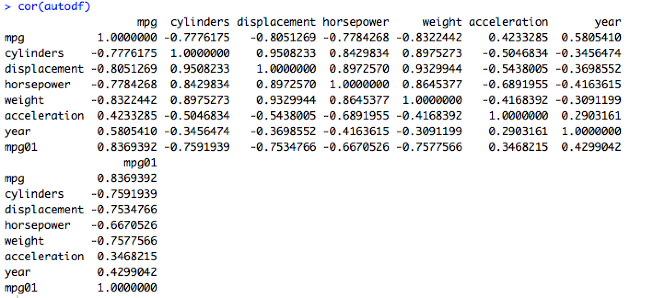

**(c) Split the data into a training set and a test set.**

set.seed(121)

sample = sample.int(n = nrow(autodf), size = floor(0.75*nrow(autodf)),replace = F)

train = autodf[sample,]

test = autodf[-sample,]

We split the data training and testing in two parts 75% and 25% respectively.

We generate random number of rows for this through sample command and divide the data accordingly.

**(d) Perform LDA on the training data to predict mpg01 using the variables that seemed most associated with mpg01 in (b). Report all the parameter estimates. What is the test error of the model obtained?**

library(MASS)

model_lda = lda(mpg01~cylinders+horsepower+displacement+weight, data = train)

model_lda

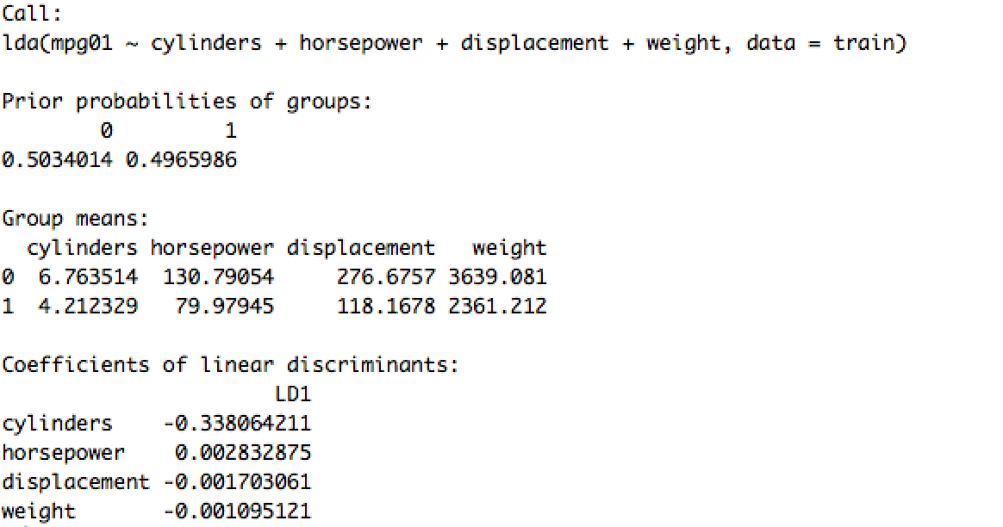

pred_lda = predict(model_lda,test)

names(pred_lda)



table(pred_lda$class,test$mpg01)

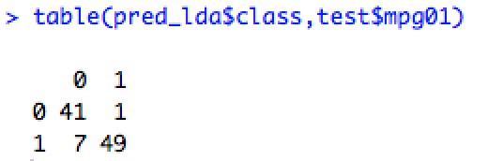

mean(pred_lda$class!=test$mpg01)



We can see that the model_lda output shows that π1_hat = 0.496 and π2_hat = 0.503, which means that 49.6% of the training observations corresponds to mpg01 is 0 and 50.3% of the training observations corresponds to mpg01 is 1. Group means μk are the average of each predictor within each class. The coefficients of linear discriminants output provide the linear combination of the four predictors we are considering namely displacement, horsepower, weight and cylinders. The coefficients for cylinders id -0.338, for horsepower is 0.00283, for displacement is -0.0017 for weight is -0.00109.

We can see from the confusion matrix that number of responses predicted right are 41+49=90

and 7+1=8 are wrong.

The test error is 8.1%

**(e) Perform QDA on the training data to predict mpg01 using the variables that seemed most associated with mpg01 in (b). Report all the parameter estimates. What is the test error of the model obtained?**

model_qda = qda(mpg01~cylinders+horsepower+weight+displacement, data = train)

model_qda

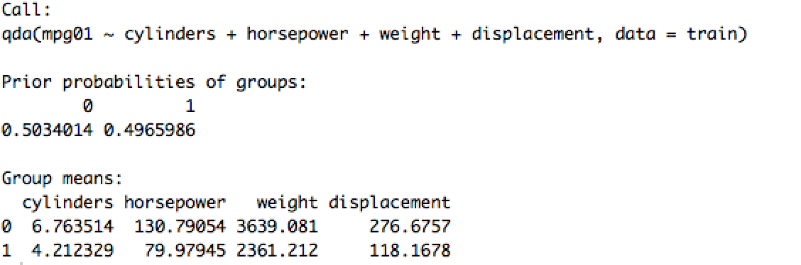

pred_qda= predict(model_qda,test)

names(pred_qda)



table(pred_qda$class,test$mpg01)

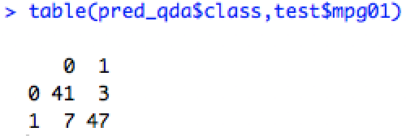

mean(pred_qda$class!=test$mpg01)



the model_qda output shows that π1_hat = 0.496 and π2_hat = 0.503 which means that 49.6% of the training observations corresponds to mpg01 is 0 and 50.3% of the training observations corresponds to mpg01 is 1. Group means μk are the average of each predictor within each class.

The confusion matrix shows that the responses predicted right are 41+47=88 and wrong are 7+3=10.

The test error for QDA is 10.2%

(f) Perform logistic regression on the training data to predict mpg01 using the variables that seemed most associated with mpg01 in (b). Report all the parameter estimates. What is the test error of the model obtained?

model_logit = glm(mpg01~cylinders+displacement+horsepower+weight, family = binomial(link = 'logit'),data = train)

model_logit

find below the coefficients for logistic model(model_logit). For cylinders it is 0.286, for displacement -0.014, for horsepower -0.0432, for weight -0.00216

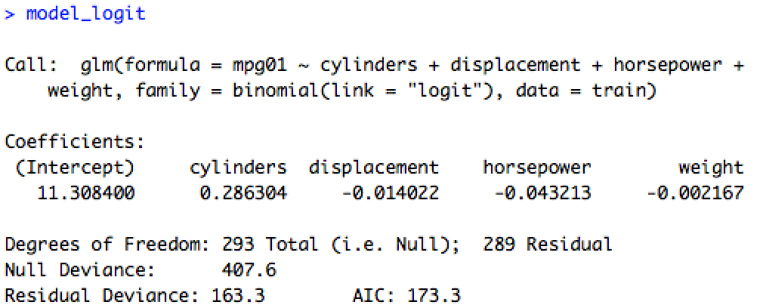

pred_logit=predict(model_logit,test)

pred_logit = as.numeric(pred_logit>0.5)

table(pred_logit,test$mpg01)

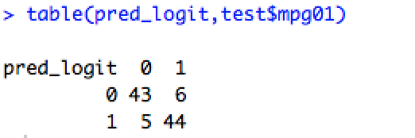

mean(pred_logit!=test$mpg01)



the confusion matrix shows that reponses predicted right are 43+44=87 and wrong are 5+6=11

The test error for logistic model is 11.2%

**(g) Using logistic regression, LDA, and QDA to estimate the probability that a dodge challenger se car with the following setting (cylinders = 6, displacement = 400, horsepower = 110, weight = 3000, acceleration = 15, year = 75, origin = 1) gets high gas mileage.**

new_test= data.frame(cylinders = 6, displacement = 400, horsepower = 110, weight = 3000, acceleration = 15, year = 75, origin = 1)

new_pred_lda = predict(model_lda,new_test)

new_pred_lda$class



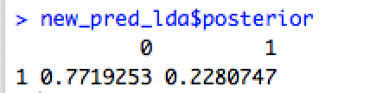

The probability of the above given value for a car being in high mileage group(mpg01=1) is 22.8% and low mileage(mpg01=0) is 77.19%

Hence we predict the class as low mileage one.

new_pred_qda = predict(model_qda,new_test)

new_pred_qda$class

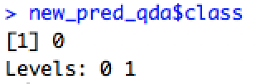

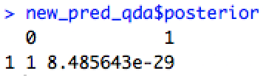

The probability of the above given value for a car being in high mileage group(mpg01=1) is 8.485*10^-27% and low mileage(mpg01=0) is ~100%

Hence we predict the class as low mileage one.

new_pred_logit= predict(model_logit,new_test, type= "response")

as.numeric(new_pred_logit>0.5)

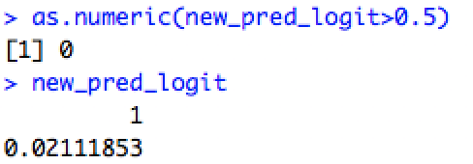

The probability of the above given value for a car being in high mileage group(mpg01=1) is 2.1%

Hence we predict the class as low mileage one.

**(h) (Graduate students only) Perform KNN on the training data, with several values of K, in order to predict mpg01. Use only the variables that seemed most associated with mpg01 in (b). What test errors do you obtain? Which value of K seems to perform the best on this data set?**

library(class)

train.X = cbind(cylinders,horsepower,weight,displacement)[sample,]

test.X = cbind(cylinders,horsepower,weight,displacement)[-sample,]

train.mpg01 = mpg01[sample]

test.mpg01 = mpg01[-sample]

knn.pred = knn(train.X,test.X,train.mpg01,k=1)

table(knn.pred,test.mpg01)

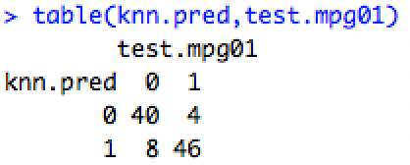

mean(knn.pred!=test.mpg01)



The test error for k=1 is 12.2%

knn.pred = knn(train.X,test.X,train.mpg01,k=2)

table(knn.pred,test.mpg01)

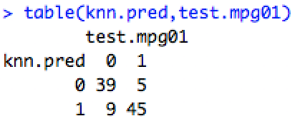

mean(knn.pred!=test.mpg01)



The test error for k=2 is 14.2%

knn.pred = knn(train.X,test.X,train.mpg01,k=10)

table(knn.pred,test.mpg01)

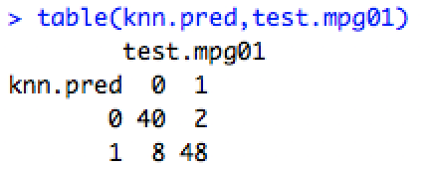

mean(knn.pred!=test.mpg01)



The test error for k=10 is 10.2%

knn.pred = knn(train.X,test.X,train.mpg01,k=100)

table(knn.pred,test.mpg01)

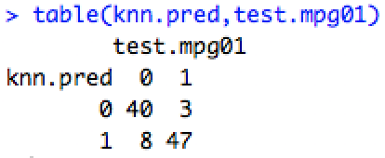

mean(knn.pred!=test.mpg01)



The test error for k=2 is 11.2%

We can see above from test error that the best value for test errors come for K=10.

**3. Consider a dataset (X; Y) in which Y is output and X represents inputs. Let n be the number of observations and p be the number of inputs in the dataset. Consider a special case n = p = 1.**

**(a) Choose a few random values of Y and lambda, plot (1) and (2) as a function of beta, and their minima on the graphs. Verify that these minima**



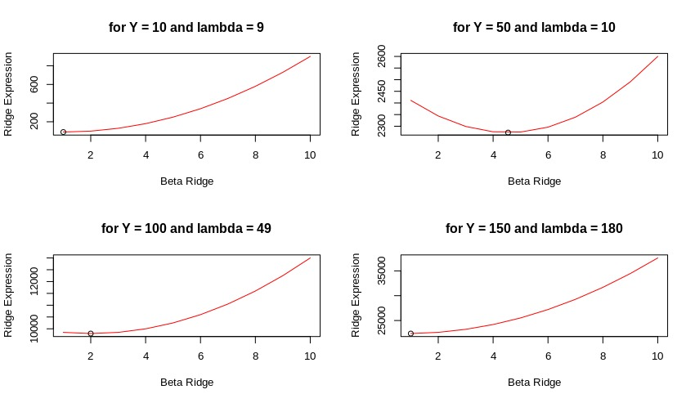

par(mfrow=c(2,2))

y=10,50,100,150 #use value one by one

lambda=9,10,49,180 #use value one by one

plot_ridge = function(y, lambda) {

curve((y - x)^2 + (lambda*x^2),from=1, to= 10,xlab="beta",ylab="Ridge Expression", col=”Red”)

}

ridge = function(beta){

return ((y - beta)^2 + (lambda*beta^2))

}

val_ridge = lapply(1:10,ridge)

ridge_optimise = optimise(ridge,1:10)

plot_ridge(10,9)

points(ridge_optimise$minimum,ridge_optimise$objective)

print(ridge_optimise$minimum)

We can see that the minima corresponding to the value for Y=10 and lambda=9 should be at 10/(9+1)=1 and from optimize function we can see the minimum is at

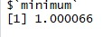

For Y=10 and lambda=9 should be at 50/(10+1)=4.54 and from optimize function we can see the graph’s minimum is at

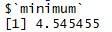

For Y=100 and lambda=49 should be at 100/(49+1)=2 and from optimize function we can see the graph’s minimum is at

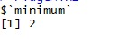

For Y=150 and lambda=180 should be at 150/(18 0+1)=0.828 and from optimize function we can see the graph’s minimum is at

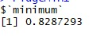

y=32,22,18,22 #use value one by one

lambda=5,8,4,19 #use value one by one

plot_lasso = function(y, lambda) {

curve((y - x)^2 + (lambda*abs(x)),from=1, to= 10,xlab="beta",ylab="Ridge Expression", col=”Red”)

}

ridge = function(beta){

return ((y - beta)^2 + (lambda*beta^2))

}

val_lasso = lapply(1:10,ridge)

lasso_optimise = optimise(ridge,1:10)

plot_lasso(10,9)

points(lasso_optimise$minimum,lasso_optimise$objective)

print(lasso_optimise$minimum)

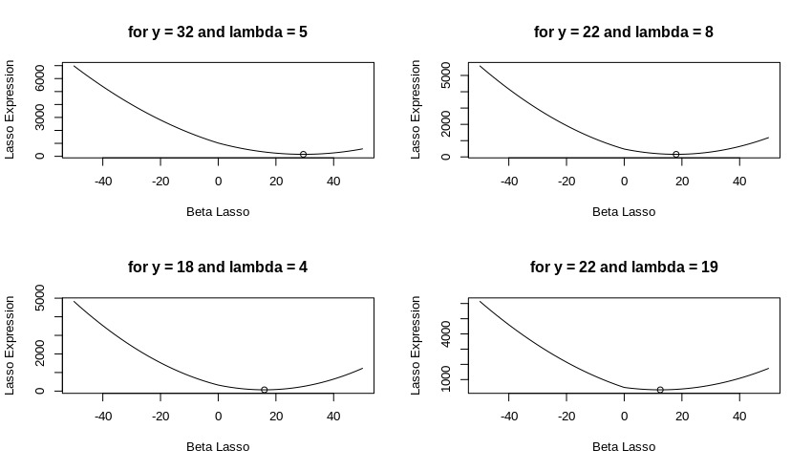

The minimum in graphs has been verified below

For Y=32 and lambda=5 we can see the minimum is at 32-(5/2) for Y<lambda/2



For Y=22 and lambda=8 we can see the minimum is at 22-(8/2) for Y<lambda/2



For Y=18 and lambda=4 we can see the minimum is at 18-(4/2) for Y<lambda/2



For Y=22 and lambda=19 we can see the minimum is at 22-(19/2) for Y<lambda/2



**(b) Choose a few random values of Y , and for each value of Y , plot ^ _ridge and ^ _lasso**

**on the same axes, as functions of _. Describe the observations from the plots.**

y=10,50,100,1 #use value one by one

beta_ridge = function(lambda){y/(1+lambda)}

beta_lasso = function(lambda) {

comp=lambda/2

if(y > comp){

y-comp

}

else if(y < -comp){

y+comp

}

else{

0

}

}

lambda = seq(-50,50,1)

matplot(lambda,cbind(beta_ridge(lambda),beta_lasso(lambda)),type="l",col=c("green","red"), xlab = "Lambda", ylab = "Beta_hat", main = "For Y=1")

We can see from the plot that the value of Y affects the slope of the graph for lasso method and acts as a multiplication factor for ridge method values.

The general trend we see in all graphs for ridge is that with increase in the value of lambda the beta falls sharply and the stays constant after certain value but never reaches zero. For lasso with increase in value of lambda the beta reaches zero.



**4. Generate the data fXi1;Xi2;Xi3; Yig200**

**i=1 using the model Yi = 10 + 1:5Xi1 􀀀 0:3Xi2 +10:7Xi3 + _i, where Xi1 _ Unif(0; 4);Xi2 _ Unif(3; 8);Xi3 _ Unif(􀀀-1; 5); _i _N(0; 3). Now add _ve more predictor variables Z1 = 1:5X1X2;Z2 = 􀀀3:6X1X3;Z3 =X2X3;Z4 _ N(20; 40);Z5 _ N(10; 1).**

X1 = runif(200,0,4)

X2 = runif(200,3,8)

X3 = runif(200,-1,5)

ebsilon = rnorm(200,0,3)

Z1=1.5 * X1 * X2

Z2 = -3.6* X1 *X3

Z3 = X2 * X3

Z4 = rnorm(200,20,40)

Z5 = rnorm(200,10,1)

Y = 10+1.5 *X1-0.3*X2+10.7*X3+ebsilon

X=cbind(X1,X2,X3,Z1,Z2,Z3,Z4,Z5)

**(a) Show the Lasso solution path?**

library("lars")

fit.lars = lars(X,Y, type="lasso",trace=TRUE)

plot(fit.lars)

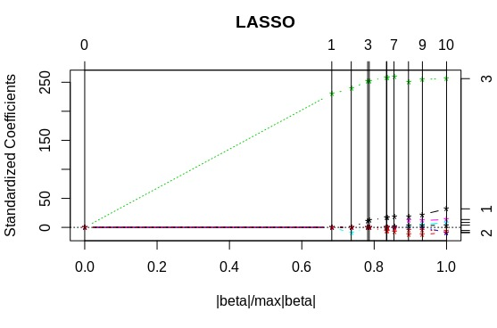

**(b) What is the tuning parameter that minimizes the cross-validation error? What is the corresponding minimum cross-validation error?**

library(glmnet)

fit = glmnet(X,Y)

plot(fit)



cvfit = cv.glmnet(X,Y)

plot(cvfit)



bestlam =cvfit$lambda.min



min(cvfit$cvm)

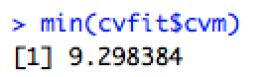

We can see the tunning parameter (lambda) is 0.0594 and the corresponding crossvalidation error is 9.29

**(c) What are the significant variables chosen by the Lasso? Interpret the result.**

lasso.coef=predict(fit ,type ="coefficients",s=bestlam )[1:9,]

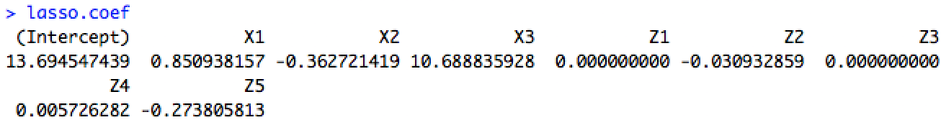

we can see the value for coefficients for Z1 and Z3 is zero hence they are not significant to the model and hence they are omitted from the fitted model.

**(d) What is the Fitted model?**

updated_X=cbind(X1,X2,X3,Z2,Z4,Z5)

fit_updated=glmnet(updated_X,Y)

plot(fit_updated)



**5. Consider the data set College in the R package ISLR. The response variable is the number of applications received and the other variables are the predictors.**

**(a) Split the data set into a training set and a test set.**

library(ISLR)

college_df= data.frame(College)

attach(college_df)

set.seed(101)

train=sample.int(n=nrow(college_df),size = floor(nrow(college_df)*0.75),replace = F)

train_df=college_df[train,]

test_df=college_df[-train,]

test.response=Apps[-train]

**(b) Fit a linear model using least squares on the training set, and report the test error obtained.**

App_fit=lm(Apps~., data = train_df)

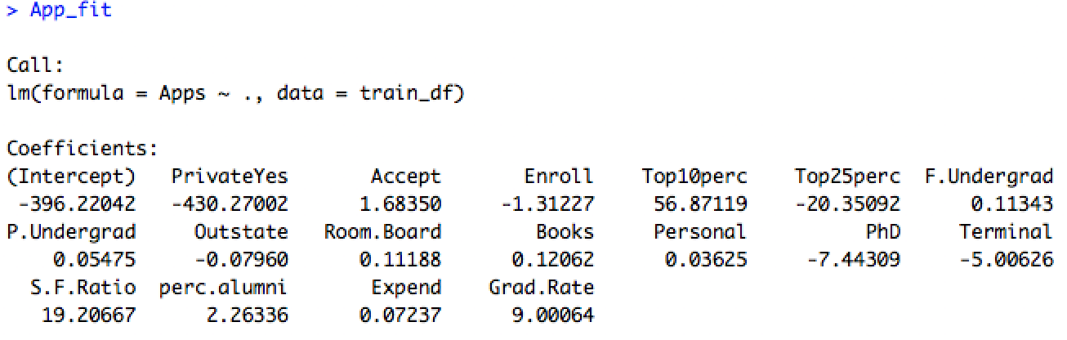

pred_apps=predict(App_fit,test_df)

mean((pred_apps-test.response)^2)



The mean sq error is 1095071

**(c) Fit a ridge regression model on the training set, with _ chosen by cross-validation. Report the test error obtained.**

train_mat = model.matrix(Apps ~ ., data = train_df)

test_mat = model.matrix(Apps ~ ., data = test_df)

grid = 10 ^ seq(4, -2, length = 100)

fit.ridge = glmnet(train_mat, train_df$Apps, alpha = 0, lambda = grid)

cv.ridge = cv.glmnet(train_mat, train_df$Apps, alpha = 0, lambda = grid)

bestlam.ridge = cv.ridge$lambda.min

bestlam.ridge



pred_ridge = predict(fit.ridge, s = bestlam.ridge, newx = test_mat)

mean((pred_ridge - test.response)^2)



The mean sq error is 1094854

**(d) Fit a lasso model in the training set, with _ chosen by cross-validation. Report the test error obtained, along with the number of non-zero coe_cient estimates.**

fit.lasso = glmnet(train_mat, train_df$Apps, alpha = 1, lambda = grid)

cv.lasso = cv.glmnet(train.mat, train_df$Apps, alpha = 1, lambda = grid)

bestlam.lasso = cv.lasso$lambda.min

bestlam.lasso



pred_lasso = predict(fit.lasso, s = bestlam.lasso, newx = test.mat)

mean((pred_lasso - test.response)^2)

predict(fit.lasso, s = bestlam.lasso, type = "coefficients")

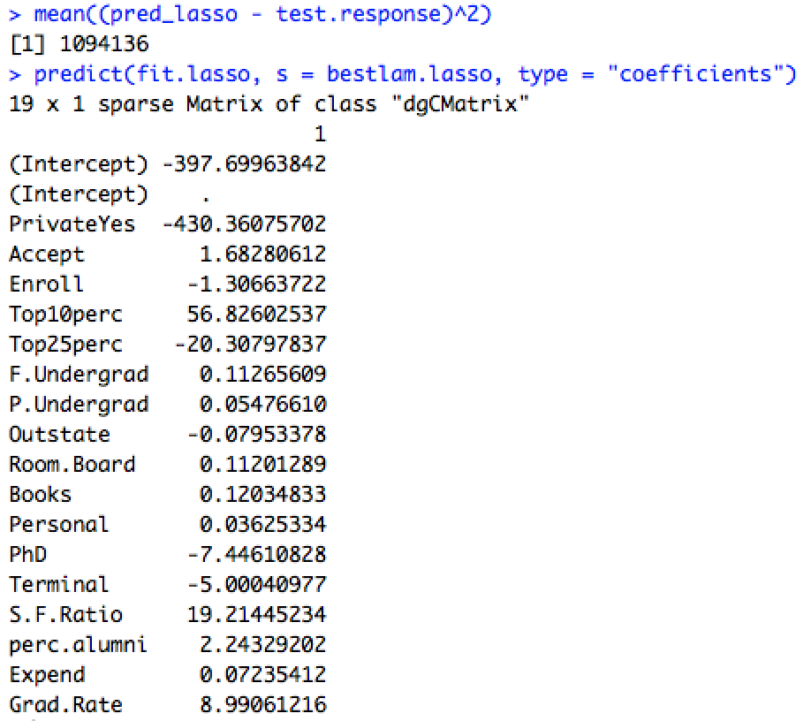

The mean sq error is 1094136

There are no non-zero coefficients for independent variable.

**(e) Comment on the results obtained. How accurately can we predict the number of college applications received? Is there much difference among the test errors resulting from these three approaches?**

For calculating how accurately we can predict results we have to calculate R^2 value for every model

test_avg <- mean(test_df$Apps)

lm_r2 <- 1 - mean((pred_apps - test_df$Apps)^2) / mean((test_avg - test_df$Apps)^2)

ridge_r2 <- 1 - mean((pred_ridge - test_df$Apps)^2) / mean((test_avg - test_df$Apps)^2)

lasso_r2 <- 1 - mean((pred_lasso - test_df$Apps)^2) / mean((test_avg - test_df$Apps)^2)

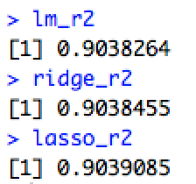

We can see that all models perform accurately but the best accuracy is of lasso method marginally.